**Collector install**

**Purpose**

Collectors serve as the collection point for all your data. Deploying a standalone Collector will also require deploying at least one Aggregator prior to collector installation. The Aparavi platform requires at least one of each component or a hybrid Aggregator-Collector to collect data from your infrastructure. All data collected from your sources will remain on the Aggregator and is not transferred to the Aparavi platform itself.

**Usage**

**Install requirements**

* Supported OS – see [Supported Platforms](https://support.aparavi.com/knowledge-base/supported-platforms/) for the currently available options
* CPU – 4 cores minimum, more cores recommended for more parallel tasks
* RAM – 8GB minimum, 16GB recommended
* Disk – 150GB minimum free space

**Install process**

* Once the Windows or Linux server that will be used as the Collector has been prepared, open the Aparavi portal within the designated server to begin the deployment process.
* Using the tree on the left panel, navigate to the Aggregator that you want to to use for the Collector to connect.
* Click on that level object to bring up the menu, scroll down to and click **+ Add Object.** The sub-menu should appear with multiple: **Add Aggregator Group**, **Add Collector** and **Add Worker**.

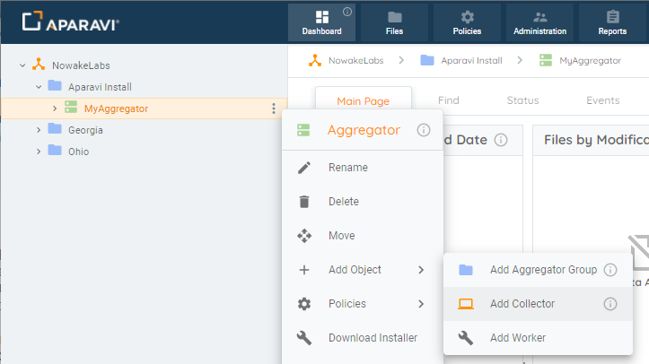Add Object

* Select **Add Collector**. The Add Collector modal will appear. At this point you can fill in the required information.
  + **Collector Name** – the name for the collector within the Aparavi portal
  + **Platform** – Windows or Linux
  + **Connect To** – hostname or IP of the Aggregator used for the Collector to connect
  + **App Program Folder** – location for the install (Windows only)
  + **App Data Folder** – location for the user data

Ein Bild, das Text enthält.
Add New Collector (Windows)

Ein Bild, das Text enthält.
Add New Collector (Linux)

* Select the OK button once all required information has been entered. This will initiate the Collector installer download locally.

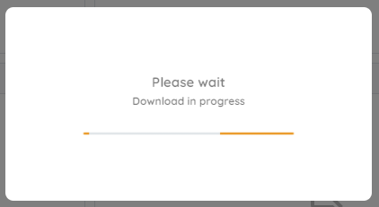Download in progress

**Windows installs**

* If the installer was not downloaded on the server designated as the Collector, the installation file will need to be copied to the designated Collector server. Launch the installer to proceed with the Collector installation. The installer will extract, and the installation is completely automated.

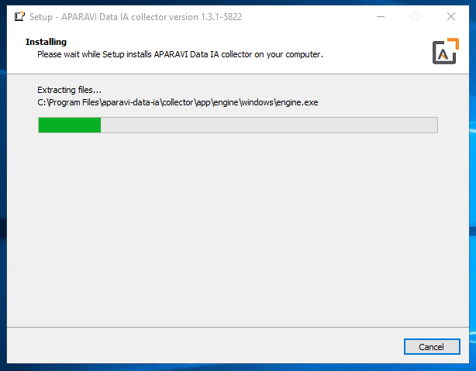Collector installing (Windows)

**Linux installs**

* When download completes, select the option to **save** the downloaded file, which will place the file in the current user’s Download directory. Open a terminal and set the default location to the Download directory, in most cases using this command:

cd ~/Downloads

* The downloaded filename will include the Aggregator as named with the version number and a .run file extension. The file must be set executable in order to launch the installation. Using an example filename, here is the command to set the file executable:

chmod a+x install-AppAggLinux-1.3.1-5822.run

* The installation can now be started and must be run either while logged in a root or by using the sudo command. Here is an example of the latter case:

sudo ./install-AppAggLinux-1.3.1-5822.run

* The installation will run, showing progress during the process until complete, with no further user action needed, as shown:

Ein Bild, das Text enthält.
Collector installing (Linux)

**Install complete**

* Once the installation is complete, the Aparavi Data IA Collector service will automatically start. Within the portal interface, the new deployed collector will automatically come online and is now ready for service.

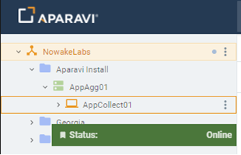Collector online